# Subject code: CP2408

# Subject Title: Design Thinking and Creative IT Industries

Assessment 2: Project Documentation         JCU Singapore

 **Group Task Cover Sheet**

Subject code: CP2408

|  |  |  |  |  |  |  |  |  |  |
| --- | --- | --- | --- | --- | --- | --- | --- | --- | --- |
| Student Family Name | Student Given Name | JCU student Number | | | | | | | |
| Sathasivam | Sanjay Kumar | 1 | 3 | 2 | 9 | 4 | 9 | 9 | 3 |
| Bogogolelo | Reuben | 1 | 3 | 2 | 7 | 2 | 5 | 6 | 6 |
| Ch’ng | Kok Liang | 1 | 3 | 4 | 1 | 7 | 6 | 7 | 3 |
| Lum | Brandon | 1 | 3 | 3 | 7 | 9 | 3 | 3 | 9 |
| Assessment Title | Project documentation | | | | | | | | |
| Due Date | 27 January 2017 | | | | | | | | |
| Lecturer Name | Mr Randy Zhu | | | | | | | | |
| Tutor Name | Mr Randy Zhu | | | | | | | | |

Student Declaration

1.This assignment is our original work and no part has been copied/ reproduced from any other person’s work or from any other source, except where acknowledgement has been made (see Learning, Teaching and Assessment Policy 5.1)

2.This work has not been submitted for any other course/subject (see Learning, Teaching and Assessment Policy 5.9).

3.This assignment has not been written for us.

4.We hold a copy of this assignment and can produce a copy if requested.

5.This work may be used for the purposes of moderation and identifying plagiarism.

6.We give permission for a copy of this marked assignment to be retained by the College

for benchmarking and course review and accreditation purposes.

Learning, Teaching and Assessment Policy

5.1. A student who submits work containing plagiarised material for assessment will be subject to the

provisions of the Student Academic Misconduct Requirements.

Note definition of plagiarism and self plagiarism in Learning, Teaching and Assessment Policy:

Plagiarism:

reproduction without acknowledgement of another person’s words, work or expressed thoughts from any source. The definition of

words, works and thoughts includes such representations as diagrams, drawings, sketches, pictures, objects, text, lecture hand-outs, artistic works and other such expressions of ideas, but hereafter the term ‘work’ is used to embrace all of these. Plagiarism comprises not only direct copying of aspects of another person’s work but also the reproduction, even if slightly rewritten or adapted, of someone else’s ideas. In both cases, someone else’s work is presented as the student’s own.

Under the Australian Copyright Act 1968 a copyright owner can take legal action in the courts against a party who has infringed their copyright. Self Plagiarism: the use of one’s own previously assessed material being resubmitted without acknowledgement or citing of the original.

1. The names of all team members and their roles during each iteration

Through discussion and work allocation, we have decided that it would be better and more efficient to stick to the same roles for each iteration of our MVP. We assigned a general role for each member, based off Belbin’s team roles.

|  |  |
| --- | --- |
| Name | Team Role |
| Reuben | Specialist |
| Brandon | Coordinator |
| Sanjay | Implementer |
| Kok Liang | Completer Finisher |

Reuben: Specialist.

Reuben is the more extroverted member in our team. He is very comfortable in socializing with others, and often brings accurate insights as to how the target users might think and react.

As such, Reuben has been assigned the task of leading the interviews with target users to test our MVPs and gather feedback. He is also in-charge of leading the evaluations of those feedback, where he makes the final decisions on closing statements after listening to the team opinions.

Brandon: Coordinator

Brandon takes up the leadership role of the team. He ensures that all the opinions and suggestions of the team members are being considered thoroughly and alternatives explored before coming to conclusions.

Brandon plays a smaller role after the allocation of tasks. He keeps track of the progress of group members, provides opinions on directions and updates relevant documentation as needed. He headed the initial part of the assignment, where assumptions and hypotheses are deducted, as well as drafting an initial interview plan

Sanjay: Implementer

Sanjay is the technical expert of the group. He has a wider skillset regarding matters such as design and coding. Respecting his skill, the group has given him the primary task of constructing the MVPs.

Given Sanjay’s expertise, we are able jump straight into the creation of digital prototypes. Upon the conclusion of discussions related to MVP, Sanjay will create/add features according to what the team’s direction is. He is also able to provide constructive feedback for why he thinks certain features we want to add is not advisable, allowing to team to go back to the drawing board with a renewed understanding.

Kok Liang: Completer Finisher

Kok Liang is the timekeeper of the team. He often helps to conduct an extensive review of each team member’s work, offering alternatives, and tries to ensure that the work is free of error.

Kok Liang has been given the role of managing the records of all team meetings and discussions. He manages the schedule of these meetings and ensures that the team does not get side-tracked during the discussions. Kok Liang also assists Reuben with the interviews, helping to document the data obtained and bounces ideas between the team.

As our roles are set in stone for each iteration of the project, the team is more comfortable dealing with any potential problems regarding the assignment. Having to constantly shift roles and priorities can be confusing, and end up causing us to spend unnecessary time to adapt.

That said, the team still constantly makes it a point to discuss actions and objectives, keeping everyone updated on the final progress of the project. We would approach each other for advice and opinions, should any doubts arise.

2. How the four-stage Lean UX process was used during each iteration of the project work:

The process was utilized to its fullest extent in our construction of MVP#1:

**Think:**

The creation of our first MVP would pick up right after the end of our assignment one.

However, we decided to revisit the decisions so as to construct a MVP that would better suit our end goal.

We do not want to have to go back to the drawing board with each iteration due to user feedback being overly negative.

Therefore, we went back and revised the problem statement:

“We have observed that local community events, such as Chinese New Year celebrations and Deepavali, might not be accommodating enough for the immigrants, either due to a lack of information of said events or for the fear of the lack of hospitality from the locals themselves, causing them to feel excluded and alienated.”

We came up with prioritised assumptions:

With regards to the user’s acclimatisation to Singapore:

* Read and understand basic english.
* Seeking to create better relationships with the locals
* Have little to no idea of the existing cultures in Singapore

With regards to the website, users will be able to:

* Have basic web browsing skills
* Find the website easy to navigate.
* Host events
* Locate different events based on their preference.
* Provide feedback through the website.
* Allow the website to send notifications to their phones and/or emails

...and prioritised hypotheses: Creating key features of our website:

1. We believe that having the default language of the website to be in english for the users will allow them to easily understand and navigate through the content.
2. We believe in creating a user database to allow the user to interface with the website with his/her own profile
3. We believe in compiling a database of events, which includes all past and upcoming events, for users to view and express interest in.
4. We believe in allowing notifications to be sent via email or sms for the user to allow for them to keep track and be updated on events that they are interested in.
5. We believe that creating a feedback form on the website for the users will allow for them to give constructive comments on our website to allow for better functionality in future iterations.

**Make:**

We will be creating a website that will allow for the users to be notified of and keep track of events hosted by the local communities.

These events will be listed in the website by default as they are supported and validated by the government of Singapore.

This first MVP would be the culmination of our research and conclusions, where we would be creating it based on the list of key features we have deduced.

Drawing from and incorporating our thought process from the previous step, we decided to create a digital prototype first, rather than a paper-based one.

We prefer to have a better visualization of the MVP, and we have the technical expertise to be able to efficiently execute it.

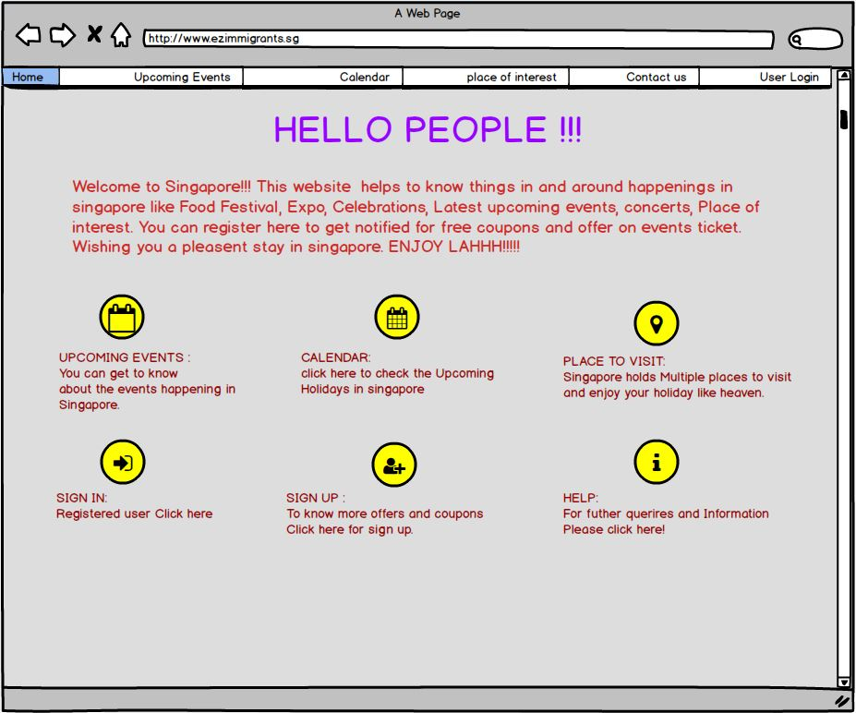

*Home page of MVP#1*

Shown below, our interview plans include questions to confirm our hypothesis and assumptions, as well as user feedback when given the MVP#1 to test. The plans would also allow us to collect the user particulars, which we can use for future development of the MVP to appeal to specific audiences if needed.

Interview plans:

We will be approaching some members of our target audience, the immigrants, to ask them some questions and test our prototype. The questions are used to confirm our assumptions and hypotheses, while the prototype will be to test the basic functionality of our first MVP.

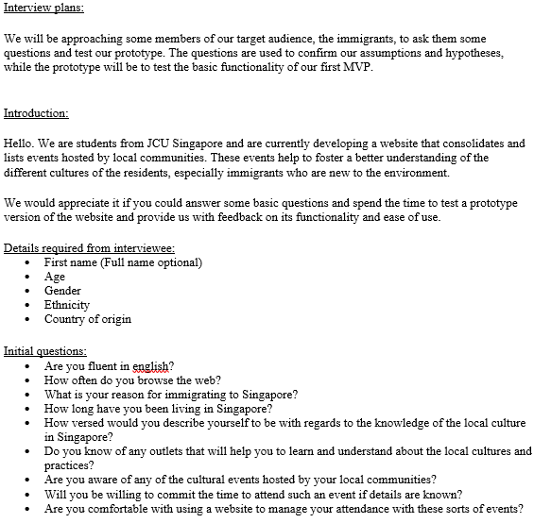

Survey for the prototype shown to the tester:

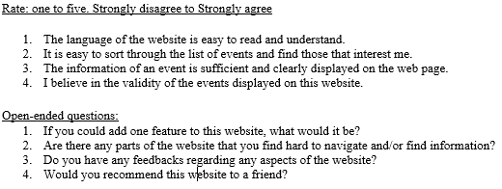

**Think and Learn**

At these stages of the Lean UX process, we proceeded to reach out to some of our target users, immigrants / potential immigrants, to put our interview plans to test and draw feedback from them.

We then use those evaluations to decide if we have indeed met the expectations of the target users, and if our initial research and discussion is successful in helping us reach the end goal.

These evaluations will lead to, in our case, addition of three more features to be incorporated into our next MVP. (These evaluations are shown in more detail at the last point)

MVP#2

We repeated the same process for MVP#2, albeit without any revisions of our assumptions and hypothesis, as we had determined them to be true as per the conclusion of our feedback. At this point, we found ourselves to be focused more on the Learning part of the process.

As with the same process of evaluating MVP#1, our motivation towards the end-goal grew stronger as user feedback was consistently positive. Taking from the few constructive comments, we decided to add one more feature and create a final MVP.

3. A record of all team meetings held during the semester;

**List of meetings**

|  |  |  |
| --- | --- | --- |
| **Meeting** | **Plan** | **Objectives** |
| 1. | 6th January 2017,  1500 -1630 HRS  JCU Singapore Campus | -        Evaluation on assignment 1 to effectively prepare for assignment 2.  -        To discuss and plan for steps to be taken for assignment 2. |
| 2. | 7th January 2017,  2100 -2200 HRS Teleconferencing (Skype) | -        To discuss and start creation of the first MVP |
| 3. | 10th January 2017  1300 - 1500HRS  JCU Singapore Campus | Compilation of work for MVP#1       Discussion of feedback and conclusions. |
| 4. | 11th January 2017  1300 - 1500 HRS  JCU Singapore Campus | -        To discuss and start creation of the second MVP |
| 5. | 14th January 2017  2000 - 2300 HRS  Teleconferencing (Skype) | Compilation of work for MVP#2       Discussion of feedback and conclusions       Discuss and start creation of the third MVP |
| 6. | 18th January 2017  1500 - 1800 HRS  JCU Singapore Campus | Compilation of work for MVP#3       Preparation of final report |
| 7. | 19th January  1300 - 1730 HRS  JCU Singapore Campus | -        Creation and preparation of pitch |

An example of a record of our meeting proceedings

Meeting 1

Date: 6th January 2017

Time: 1500 - 1630 HRS

Location: JCU Singapore Campus

Chaired by: Brandon

Recorded by: Kok Liang

Attendance: All present

**Agenda of meeting:**

1. Evaluation of assignment one
2. Discussion of approach towards assignment two

**Proceedings of meeting:**

* Evaluation of assignment one’s results
* Discussion and eventual agreement to revise problem statement/hypotheses/assumptions
* Discussion and conclusion of MVP one prototype
* Internal deadlines planned
* Conclusion of meeting with next scheduled meeting on 7th January 2017

**Action items:**

**For all:** Self reflection on any points missed during discussion.

4. Evidence of collaborative design

We came up with a collaboration plan, designed to act as a soft Standard Operating Procedure (SOP).

## Team collaboration plan

### Preferred communication methods

Our team has adopted three methods of communication; WhatsApp, Skype and email.

### 2. How to share Information and Files

We have chosen [google.docs](https://apps.google.com/intx/en_sg/products/docs/?utm_source=google&utm_medium=cpc&utm_campaign=japac-sg-en-docs-bkws-all-trial-e&utm_content=gafw&utm_term=google%20document&KWID=43700004556212039&gclid=COHk3peK8M4CFYXXvAodzGoJEw&gclsrc=ds) and gmail for information sharing as we viewed it to be more flexible, effective and convenient for members to easily access and update any information.

### 3.Plans to monitor team’s progress

To ensure that the all team members are taken on board, we have multiple meetings planned, each with a clear objective in mind. There is also an option to call an emergency meeting if necessary.

**4. Team culture or rules**

We have agreed on the below rules;

* Members should attend and be punctual to all meetings as agreed.
* Active participation and cooperation by members has been emphasized.
* Should respect other members’ views.

### 5. Preferred conflict management style

With regards to conflict management, the team has agreed to try hard to avoid conflicts. In case of any conflicts arising, the following mechanisms has been put in place;

* Where there is misconduct by any member e.g. missing meetings for no good reasons etc. the concerned member will be brought before the team to address the matter at hand.
* Communication and team collaboration are the keys to success in a group, hence it has been enforced that each member takes responsibility on their actions.

5. Evidence of usability testing for the 1st and 2nd MVPs and how observations and insights about the testing results affected the direction of the next iteration - e.g. what did the team learn from customer feedback and how did that influence the project development?

MVP#1

An example of one of our interviewees:

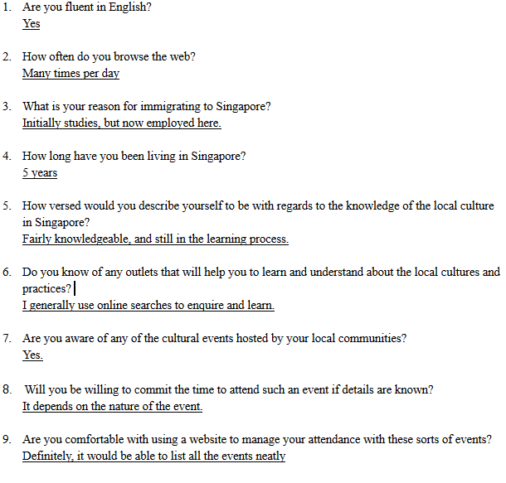

**Usability Testing of MVP #1 and MVP #2**

The main objective was to identify any usability problems, collect qualitative and quantitative data and to determine or measure satisfaction level of users with our product.

The testing was extended to both students and workers so as to get views from different levels for further develop or identify areas of improvement.

As such the prototypes were given to the users and their observations for suggestions were noted as follows;

**1.**        **Changes from MVP #1 to MVP #2**

In all the pages, we have put the map to make it convenient for the users to look for the places they want to visit.

**i.**        **From the calendar page**

We have decided not to display the calendar for the whole year with the events/ holidays, instead opting to display only the events of the respective month. This will make easy for the users to focus on the events to take place for that month.

**ii.**      **Upcoming events page**

The page has been improved by improving on some of the features such as the home, sign in/ sign up and help pages. We decided to concentrate on the upcoming events to be able to show the dates for those respective events. The map has been included in the events page as well.

**iii.**    **FAQ page**

The testing process made us realize that we need to include a FAQ page, which is useful in addressing common questions and concerns by our users.

**iv.**    **Registration and Sign In/Sign Up page**

It was suggested by the users that we should provide an option for them to register or sign in with their social network accounts like LinkedIn, Facebook, Google or Twitter.

In addition, users provide an option that our background colour might to be dull and boring to the users, which might deter any potential user activity. We have since implemented the additions successfully.

**2.**      **Changes from MVP #2 to MVP #3**

Further developments/ improvements were made to include the chat button in all pages. The chat communication channel will be open 24/7 (depending on available resources) to allow the users to gather quick responses to their questions or concerns.

As such, we are able to consolidate and create our final MVP, shown below

(Better experienced through this link: http://jc424303.studentweb.jcu.edu.sg/2408/index.html):

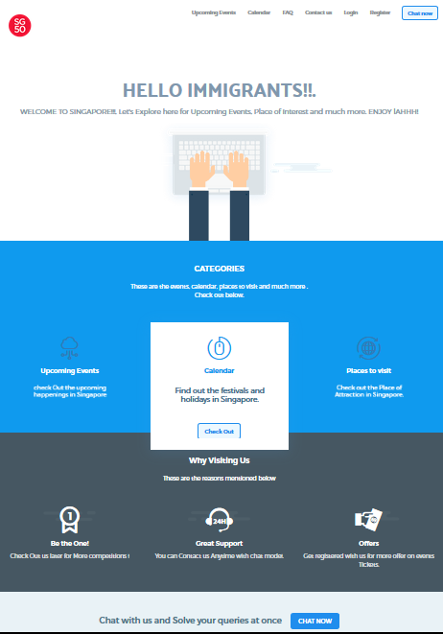

*Our home page*

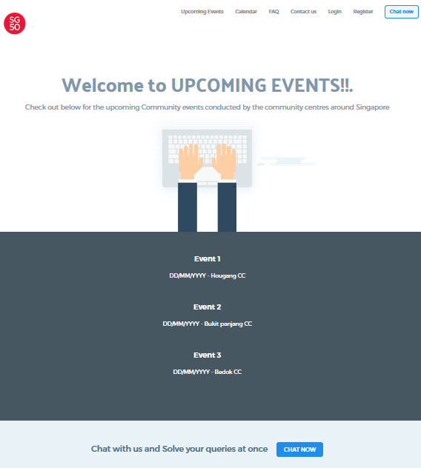

*A list of upcoming events*

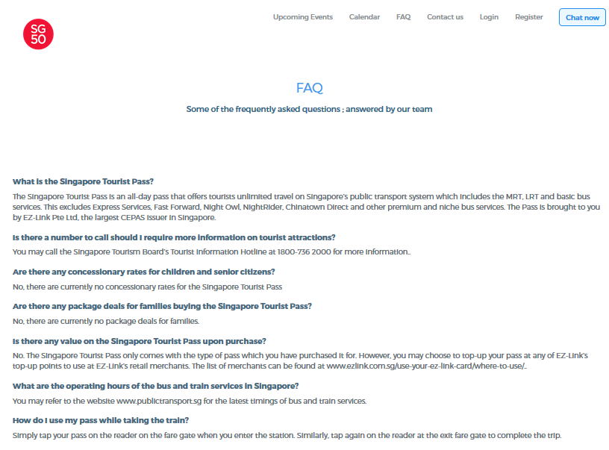

*FAQ page*

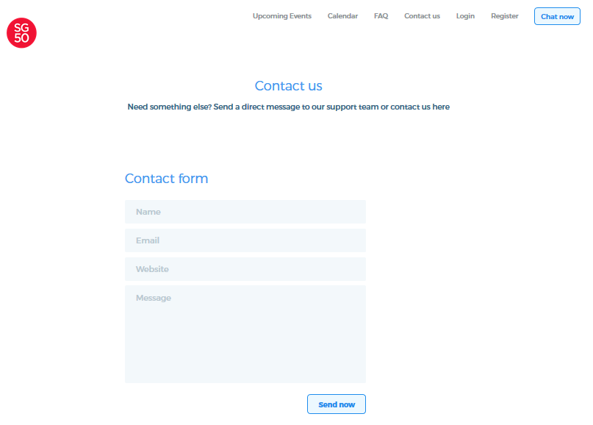

*Feedback form*

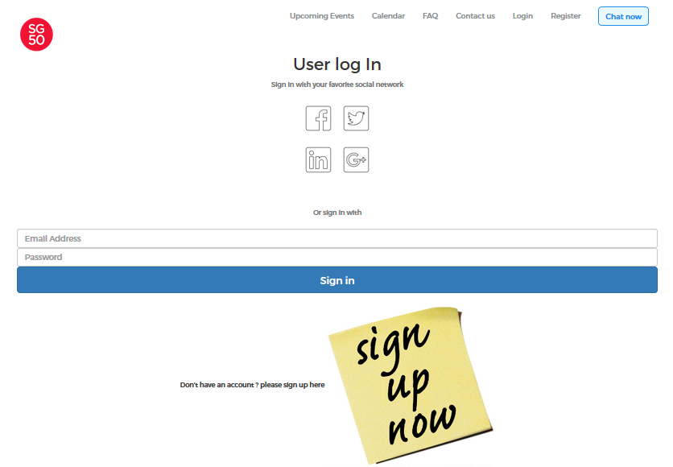

*User log in page*

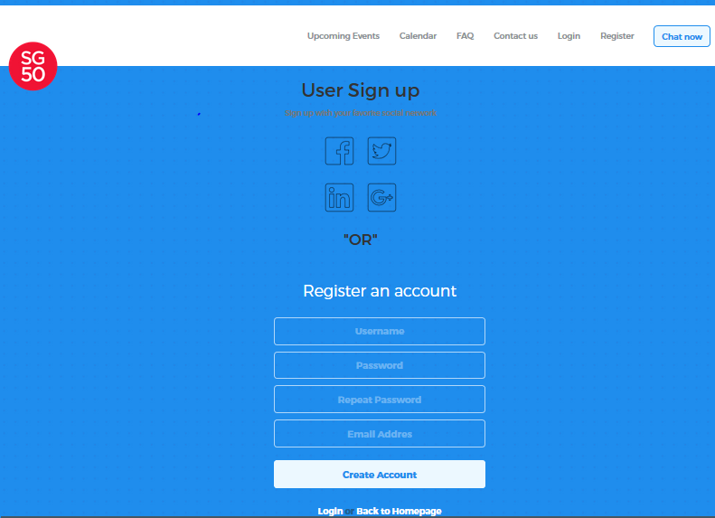

*User signup*

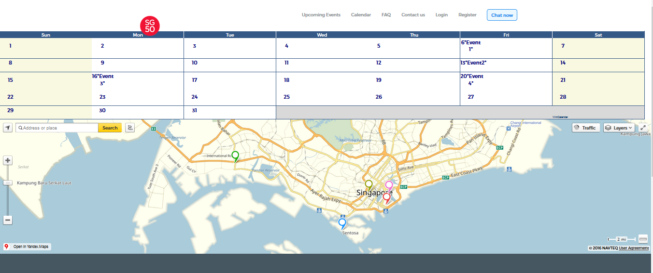

*and finally, our events page.*